**PROJECT REPORT ON**

**“Smart Shopping Cart using IOT & Google Firebase”**

**Submitted to**

**SAVITRIBAI PHULE PUNE UNIVERSITY**

**Submitted By**

**Vinit Dhas 72202980C Yash Upare 72203188C Aditya Bole 72202960J Saurabh Pisal 72203122L**

**UNDER THE GUIDANCE OF**

**Prof. Kapil Wagh**

**DEPARTMENT OF INFORMATION TEHNOLOGY NUTAN MAHARASHTRA INSTITUTE OF ENGINEERING AND TECHNOLOGY**

**Samarth Vidya Sankul Talegaon Dabhade, PUNE-410507 2024-2025**

**AFFILIATED TO**



**SAVITRIBAI PHULE PUNE UNIVERSITY**

**NUTAN MAHARASHTRA INSTITUTE OF ENGINEERING AND TECHNOLOGY**

**Department of Information Technology “Samarth Vidya Sankul” Talegaon Dabhade, PUNE-410507**



CERTIFICATE

This is certified that the project entitled

**“Smart Shopping Cart using IOT & Google Firebase”**

Submitted by

**Vinit Dhas 72202980C**

**Yash Upare 72203188C**

**Aditya Bole 72202960J Saurabh Pisal 72203122L**

Is a record of bonafide work carried out by them, in the partial fulfillment of the requirement for the award of Degree of Bachelor of Engineering (Information Technology) at NUTAN MAHARASHTRA INSTITUTE OF ENGINEERING AND

TECHNOLOGY, Pune under the University of Pune. This work is done during year 2024- 2025, under our guidance.

**Date: 06/11/2024**

**(Prof. Kapil Wagh) (Prof. Dheeraj Patil)**

**Project Guide Project Coordinator**

|  |  |  |
| --- | --- | --- |
| **(Dr. Chandrakant Kokane)**  **Head of Department** | **(Dr. S.N.Sapali)**  **Principal** | **External Examiner** |

Contents

1. INTRODUCTION 1
   1. INTRODUCTION 1
   2. PROBLEM DEFINITION 1
   3. OBJECTIVES 2
   4. SCOPE 2
   5. ORGANIZATION OF PROJECT REPORT 2
2. LITERATURE SURVEY 3
   1. LITERATURE SURVEY 4
3. SOFTWARE REQUIREMENT SPECIFICATION 7
   1. INTRODUCTION 7
      1. Problem Statement 7
      2. User Classes and Characteristics 7
      3. Assumptions and Dependencies 7
   2. FUNCTIONAL REQUIREMENT 8
      1. System Feature 1(Functional Requirement) 8
   3. NON FUNCTIONAL REQUIREMENT 8
      1. Performance Requirements) 8
      2. Safety Requirements 8
      3. Security Requirements 8
      4. Software Quality Attributes 9
   4. SYSTEM REQUIREMENT 9
      1. Software Requirements(Platform Choice) 9
      2. Hardware Requirements 9
   5. ANALYSIS MODELS: (SDLC MODEL TO BE APPLIED) 11
4. SYSTEM DESIGN 12
   1. SYSTEM ARCHITECTURE 12
   2. DATA FLOW DIAGRAM 12
      1. Level 0 Data Flow Diagram 12
   3. UML DIAGRAM 14
      1. Use-cases 14
      2. Activity Diagram 15
      3. Class Diagram 16
      4. Component Diagram 17
      5. Deployment Diagram 17
5. PROJECT PLAN 18
   1. Project Estimates 18
      1. Reconciled Estimates 18
      2. Project Resources 19
   2. OVERVIEW OF PROJECT 20
      1. TECHNOLOGY USED Android 21
   3. Collaborative Filtering 22
6. PROJECT IMPLEMENTATION 23
   1. OVERVIEW OF PROJECT 23
      1. TECHNOLOGY USED Android 23
   2. ALGORITHM 26
7. Software Testing 27
   1. Type of Testing Used 27
   2. Test Cases and Test Results 27
8. CONCLUSION 30
   1. CONCLUSION 30
   2. FUTURE SCOPE 30
9. REFERENCES 31
10. SPONSORSHIP LETTER 32

List of Figures

|  |  |
| --- | --- |
| 4.1 Architecture Diagram . . . . . . . . . . . . . . . . . . . . . . . . . . . . . . . . . | 15 |
| 4.2 DFD Level 0. . . . . . . . . . . . . . . . . . . . . . . . . . . . . . . . . . . . . . . . . | 16 |
| 4.3 DFD Level 1. . . . . . . . . . . . . . . . . . . . . . . . . . . . . . . . . . . . . . . . . | 16 |
| 4.4 Use Case Diagram . . . . . . . . . . . . . . . . . . . . . . . . . . . . . . . . . . . . | 17 |
| 4.5 Activity Diagram . . . . . . . . . . . . . . . . . . . . . . . . . . . . . . . . . . . . . | 18 |
| 4.6 Component Diagram. . . . . . . . . . . . . . . . . . . . . . . . . . . . . . . . . . . | 19 |
| 4.7 Component Diagram. . . . . . . . . . . . . . . . . . . . . . . . . . . . . . . . . . . | 19 |
| 4.8 Deployment Diagram . . . . . . . . . . . . . . . . . . . . . . . . . . . . . . . . . | 20 |

List of Tables

* 1. Literature Survey . . . . . . . . . . . . . . . . . . . . . . . . . . . . . . . . . . . . . . . . 8
  2. Size Estimation Of Current System . . . . . . . . . . . . . . . . . . . . . . . . . . 21

Chapter 1

# INTRODUCTION

## INTRODUCTION

Individuals travel to the shopping mall to buy their daily essentials. Shopping malls have spawned a new market for bill paying convenience. Customers are occasionally frustrated standing at the long queue for the billing and payment of the items purchased at the billing counter in the shopping mall. We developed a smart cart with a smartphone app to overcome these issues. This article offers a user interface to help customers to purchase the product. It will also aid in automatic bill calculation and generation at the cart itself. As the technology is developing and seeing new inventions in various fields including machine learning, artificial intelligence, internet of things and so on, there is an increase in the expectations in the consumer point of view. With the fast moving lives, the consumers absolutely have no time to stand in long queues in order to get their work done. In this paper, we are presenting a smart shopping system using Raspberry Pi controller and pi camera. The carts in the shopping malls are protocol so as to automatically bill the products put into them and the final bill is sent to a web application which can be accessed in any phone or any hand held device. The system is also subjected to anti-theft management where the system doesn’t let any customer take non-billed items.

## PROBLEM DEFINITION

Since the dawn of civilization, people have been inventing to suit their needs. More independence may be the underlying reason for creativity’s success, and this helps to improve assignments and make them smaller and easier on a daily basis. Shopping is an important activity for people who want to burn the most calories. The shopping center is a place where people go to acquire their daily necessities such as food, clothing, and electrical equipment .In this innovative society, shopping carts are used in every grocery store and supermarket to assist customers in selecting and storing the items they intend to buy. Customers often purchase the essential things, place them in their carts, and then wait for bill payment at the counter. Paying bills at the counter is a time- consuming and inconvenient process that increases the number of individuals at the counter.

## OBJECTIVES

* + - 1. To perform extensive Literature survey and component selection.
    - 2. Online simulation of the system and component testing.
    - 3. To develop a Smart billing cart system.
    - 4. To design and develop hardware interfacing of Automated billing cart systems.
    - 5. To analyze and test the functionality of the proposed system.
    - 6. To publish a paper on the proposed work.

## SCOPE

* + - To design an automated cart system to improvise the shopping experience of customers.

## ORGANIZATION OF PROJECT REPORT

* + - Chapter 2 Deals with the Project Related Work i.e. Literature Survey.
    - Chapter 3 Giving an overall view of the techniques used in the system.
    - Chapter 4 Deals with System Design.
    - Chapter 5 Implementation Part.
    - Chapter 6 with Other Specification of Project i.e. System Requirement.
    - Conclusion and at last references.

Chapter 2

# LITERATURE SURVEY

## LITERATURE SURVEY

In this chapter, we discuss various applications and methods which inspired us to build our project. We did a background survey regarding the basic ideas of our project and used those ideas for the collection of information like the technological stack, algorithms and shortcomings of our project which led us to build a better project.

1. Paper Name -: Smart Cart with Automatic Billing Author -: Chandrasekar Palanisamy, T. Sangita

Publisher-: International Journal of Engineering Research Technology, 2020.

Observation-: In this [1] paper they have made a system model where each cart will have an RFID reader and ZigBee trans-receiver implemented on it. Each product in the shop or a mall will also have an RFID tag on it. A supermarket is a place where customers come to purchase their daily using products and pay for that. So there is a need to calculate how many products sold and generate the bill for the customer. When we go to a shopping mart for shopping, we have to work to select the right product. Also, after that, it is hectic to stand in line for billing all the goods. Hence, the proposed system is the smart shopping cart system that will keep track of purchased products and also online transactions for billing using RFID and ZigBee. The system will also give suggestions for products to buy based on user purchase history from a centralized system. In this system, every product in Mart will have an RFID tag, and every cart will have a RFID Reader and ZigBee attached to it. There will be a centralized system for the recommendation and online transaction. Moreover, there will also be RFID reader at the exit door for anti-theft.

1. Paper Name-: Smart cart and billing system Author-: Dr. Subburam, Anitha R

Publisher-: Science Direct

Observation-: In this paper the smart cart is proposed which will audit the purchased product and make payment automatically using RFID tag. It will scan automatically The billing is made in the cart itself. Nowadays, shopping has become a daily activity in today’s world. We can see large queues in many shopping malls waiting for billing. The objective of our project is to overcome the problem of standing in queue and wasting time. To overcome the above problem, we are proposing a smart cart billing system that will audit the purchased products and the payment is made online automatically using the RFID tag.

It will automatically identify and scan the product and the final billing is made from the cart itself .So that customers are free from waiting in a long queue at checkout. It also provides the centralized and automated billing system using RFID. This model is a reasonable and profitable smart shopping cart handled by the IOT innovations. The primary goal is to provide a technology oriented, time saving and commercial oriented system for enhanced shopping experience. This system will also provide suggestions for the products based on user purchased history from a consolidated system. In this system, every product in the mart will have an RFID tag, and every cart will have an RFID Reader attached to it. These features will save time and make shopping easier. Overall we can gain the best shopping experience.

1. Paper Name -: Smart shopping cart for automatic billing in supermarket Author-: Thakur Prerana, Shikha Ranjana Publisher-: IJEDR 2017

Observation-: In this paper the project consists of RFID reader ,motion detection sensor, LCD, push button, switches, Zigbee. This project consists of RFID reader, motion detector sensor, Liquid Crystal Display, push buttons, switches and Zigbee. If the user wants to use smart cart functions then the start button should be pressed. When a user puts some product in a cart then its code will be detected using RFID reader and cost of a product added to the list and sensor will sense the direction of motion of the product for fault detection and buzzer will be on if fault detected. At last, the counter with the least number of queues will be detected and displayed on the cart LCD. Then, the final bill will be transferred to the counter having least waiting list using ZigBee.

1. Paper Name -: Smart shopping cart for automatic billing in supermarket Author-: Thakur Prerana, Shikha Ranjana Publisher-: IJEDR 2017

Observation-: In this paper the project consists of RFID reader ,motion detection sensor, LCD, push button, switches, Zigbee. This project consists of RFID reader, motion detector sensor, Liquid Crystal Display, push buttons, switches and Zigbee. If the user wants to use smart cart functions then the start button should be pressed. When a user puts some product in a cart then its code will be detected using RFID reader and cost of a product added to the list and sensor will sense the direction of motion of the product for fault detection and buzzer will be on if fault detected. At last, the counter with the least number of queues will be detected and displayed on the cart LCD. Then, the final bill will be transferred to the counter having least waiting list using ZigBee.

1. Paper Name-: Smart Shopping cart with Automated billing Author-: Ankush Yewatkar, Faiz Inamdar

Publisher-: IEEE

Observation-: In this [4] the author innovates a system which supports smart billing carts. Nowadays, shopping has become a daily activity in today’s world. We can see large queues in many shopping malls waiting for billing. The objective of our project is to overcome the

problem of standing in queue and wasting time. To overcome the above problem, we are proposing a smart cart billing system that will audit the purchased products and the payment is made online automatically using the RFID tag. It will automatically identify and scan the product and the final billing is made from the cart itself. So that customers are free from waiting in a long queue at checkout. It also provides a centralized and automated billing system using RFID. The proposed model is a reasonable and profitable smart shopping cart handled by the IOT innovations. The primary goal is to provide a technology oriented, time saving and commercial oriented system for enhanced shopping experience. This system will also provide suggestions for the products based on user purchased history from a consolidated system. In this system, every product in the mart will have an RFID tag, and every cart will have an RFID Reader attached to it. These features will save time and make shopping easier. Overall we can gain the best shopping experience. update the customer bill.

1. Paper Name -: Smart Shopping with Automatic billing System Authors-: Maria Pavithra, Meghana T. K. Publisher-: IJERT (International Journal of Engineering Research and Technology)

Observation-: Technology has changed so much, so is the rate of people of all ages who are attracted to electronic gadgets. In many industries, electronic devices such as smart card readers, barcodes, and RFID scanners are increasingly used. Supermarkets also need these kinds of gadgets. Currently, every person in the mall purchases the product.

|  |  |  |  |
| --- | --- | --- | --- |
| Sr.No | Title Of Paper | Author Name | Year |
| 1 | ”Smart Cart with Automatic Billing | Chandrasekar Palanisamy, T. Sangita | 1 May 2022 |
| 2 | ”Smart cart and billing system. | Dr. Subburam, Anitha R | 4, July 2022 |
| 3 | ”Smart shopping cart for automatic billing in supermarket | Duffy DQ, Schnase JL, Thompson JH, Free- man SM, CluneTL | 2012 |
| 4 | ” Smart Shopping cart with Auto- mated billing | ”Ankush Yewatkar, Faiz Inamdar | 2021 |

Table 2.1: Literature Survey

Chapter 3

# SOFTWARE REQUIREMENT SPECIFICATION

## INTRODUCTION

This software requirement specification (SRS) report expresses complete description about proposed System. This document includes all the functions and specifications with their explanations to solve related problems.

### Problem Statement

The Automated cart Billing System is a project designed to streamline and automate the billing process in supermarkets and retail stores. The system aims to enhance efficiency, reduce human error, and improve customer satisfaction by automating the calculation and processing of purchases made by customers using shopping carts. The project aims to develop a system that automates the billing process by integrating technology into shopping carts, eliminating the need for manual billing at checkout counters.

### User Classes and Characteristics

Basic knowledge of using android mobile is adequate to use this application. Knowledge of how to use a Bluetooth or WIFI and internet browser is necessary. The user interface will be friendly enough to guide the user.

### Assumptions and Dependencies

* + - * Assumptions:
        1. All the software such as android, ESP32, etc. are installed and running on the mobile and computers.
        2. Hardware is getting the power supply
      * Dependencies:
        1. It is assumed that user know his/her tasks in organizations.
        2. All parameters are as per the dataset.
        3. Well Trained dataset.

## FUNCTIONAL REQUIREMENT

### System Feature 1(Functional Requirement)

Functional requirement describes features, functioning, and usage of a product/system or software from the perspective of the product and its user. Functional requirements are also called as functional specifications were synonym for specification is design. Provide User friendly Interface and Interactive as per standards.

## NON FUNCTIONAL REQUIREMENT

### Performance Requirements

* + - * High Speed :- System should process requested task in parallel for various action to give quick response. Then system must wait for process completion.
      * Accuracy :- System should correctly execute process, display the result accurately. System output should be in user required format.

### Safety Requirements:

The data safety must be ensured by arranging for a secure and reliable transmission media. The source and destination information must be entered correctly to avoid any misuse or malfunctioning. Password generated by user is consisting of characters, special character number so that password is difficult to hack. So, that user account is safe.

### Security Requirements

Secure access of confidential data (user’s details). Information security means protecting information and information systems from unauthorized access, use, disclosure, disruption, modification or destruction. The terms information security, computer security and information assurance are frequently incorrectly used interchange- ably. These fields are interrelated often and share the common goals of protecting the confidentiality, integrity and availability of information; however, there are some subtle differences between them.

### Software Quality Attributes

1. Runtime System Qualities: Runtime System Qualities can be measured as the system executes.
2. Functionality: The ability of the system to do the work for which it was in- tended.
3. Performance: The response time, utilization, and throughput behaviour of the system.

Not to be confused with human performance or system delivery time.

1. Security: A measure of systems ability to resist unauthorized attempts at usage or behaviour modification, while still providing service to legitimate users.
2. Availability: (Reliability quality attributes falls under this category) the measure of time that the system is up and running correctly; the length of time between failures and the length of time needed to resume operation after a failure.
3. Usability: The ease of use and of training the end users of the system. Sub qualities: learn ability, efficiency, affect, helpfulness, control.
4. Interoperability: The ability of two or more systems to cooperate at runtime.

## SYSTEM REQUIREMENT

### Software Requirements (Platform Choice)

* + - * Tools - Android Studio
      * Programming Language - Android.
      * Software Version - Android Jellybean and above

### Hardware Requirements

* + - * Processor - Pentium IV/Intel I3 core.
      * Speed - 1.1 GHz.
      * RAM - 512 MB (min)
      * Hard Disk - 20GB.
      * Keyboard - Standard Keyboard.
      * Mouse - Two or Three Button Mouse
      * Monitor - LED Monitor
      * RFID Scanner
      * ESP32
      * HC-05
      * Jumper wire

## ANALYSIS MODELS (SDLC MODEL TO BE APPLIED)

One of the basic notions of the software development process is SDLC models which stands for Software Development Life Cycle models. SDLC is a continuous process, which starts from the moment, when its made a decision to launch the project, and it ends at the moment of its full remove from the exploitation. There is no one single SDLC model. They are divided into main groups, each with its features and weaknesses. Evolving from the first and oldest waterfall SDLC model, their variety significantly expanded.

The SDLC models diversity is predetermined by the wide number of product types starting with a web application development to a complex medical software. And if you take one of the SDLC models mentioned below as the basis in any case, it should be adjusted to the features of the product, project, and company. The most used, popular and important SDLC models are given below:

1. Waterfall Model.
2. Iterative Model.
3. Spiral Model.
4. V-shaped Model.
5. Agile Model

Chapter 4

# SYSTEM DESIGN

## SYSTEM ARCHITECTURE

We will use ESP32 which will be connected to an Android app using internet Hardware will be developed using an Ultrasonic Sensor and RFID scanner/reader. Whenever the user puts the product in a cart it will send a notification to the Android app. The Android app will update the price and provide a recommendation At the time of registration in the Android app, we will ask the likes of the user and based on that we will recommend the products. When the user checkout Google Pay will be open for payment.

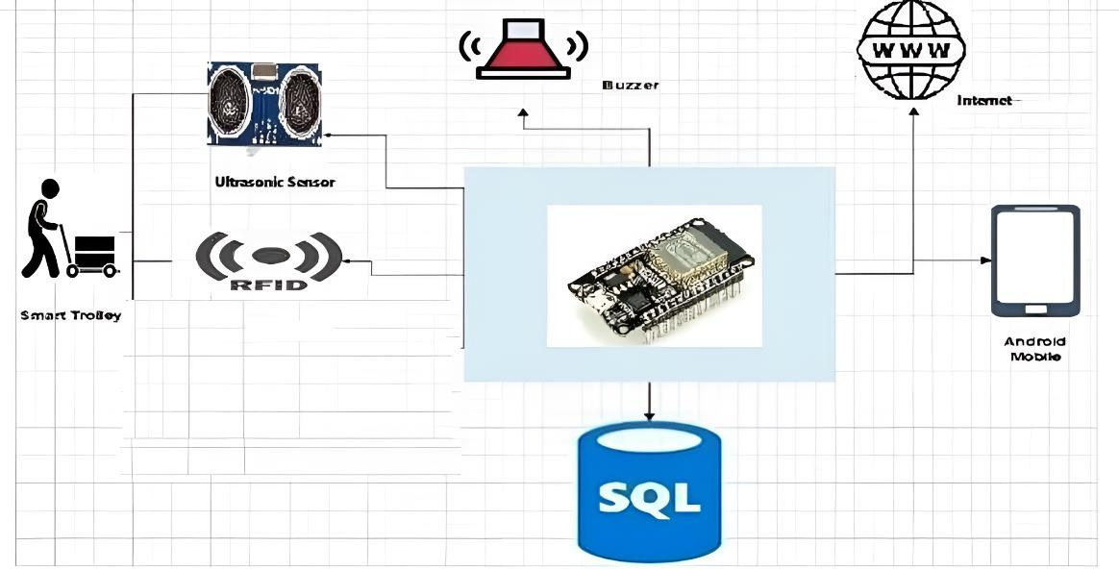

Figure 4.1: Architecture Diagram

## DATA FLOW DIAGRAM

### Level 0 Data Flow Diagram

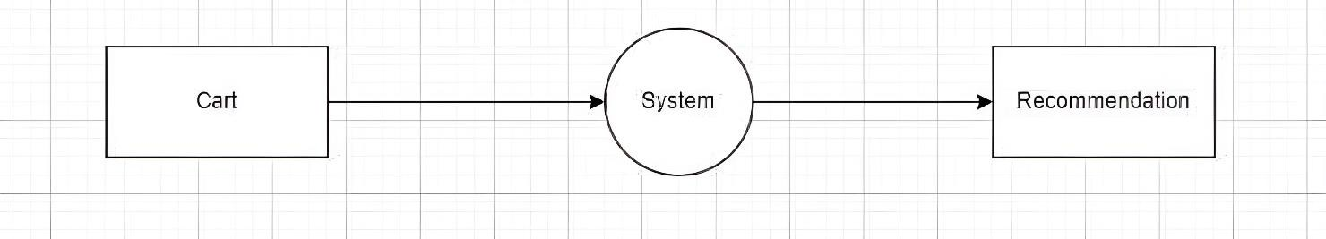

Figure 4.2: DFD Level 0

### Level 1 Data Flow Diagram

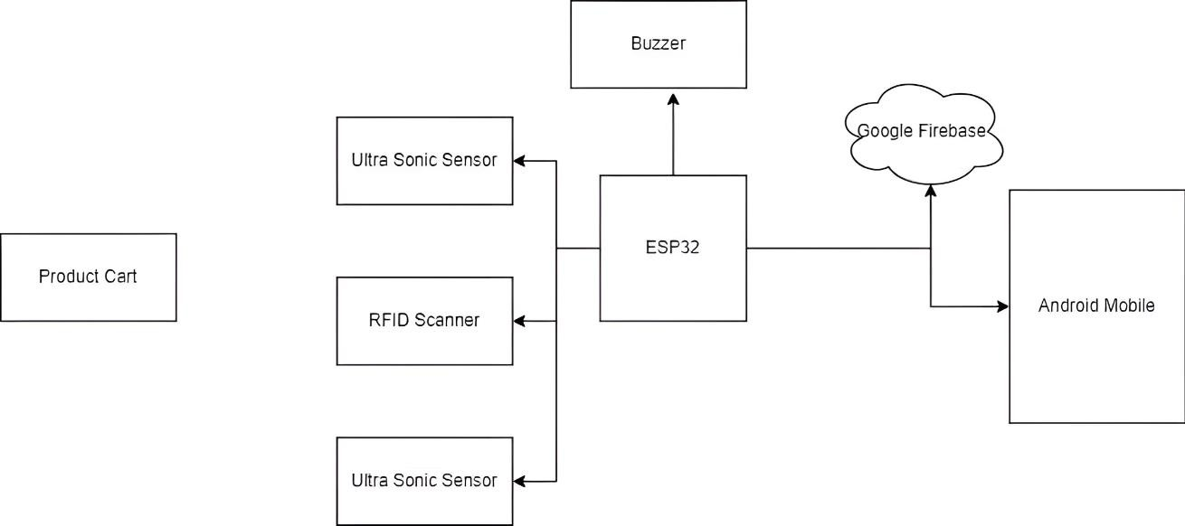

### Use-cases

Figure 4.3: DFD Level 14.3 UML DIAGRAM

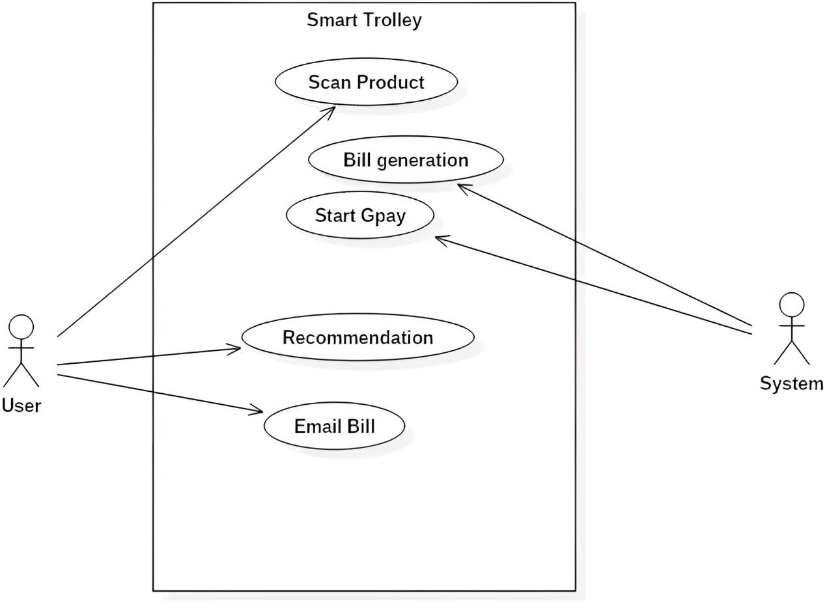

Figure 4.4: Use Case Diagram

### Activity Diagram:

Activity diagrams show the sequences of states that an object goes through, the events that cause a transition from one state to another and the actions that result into a activity diagram.

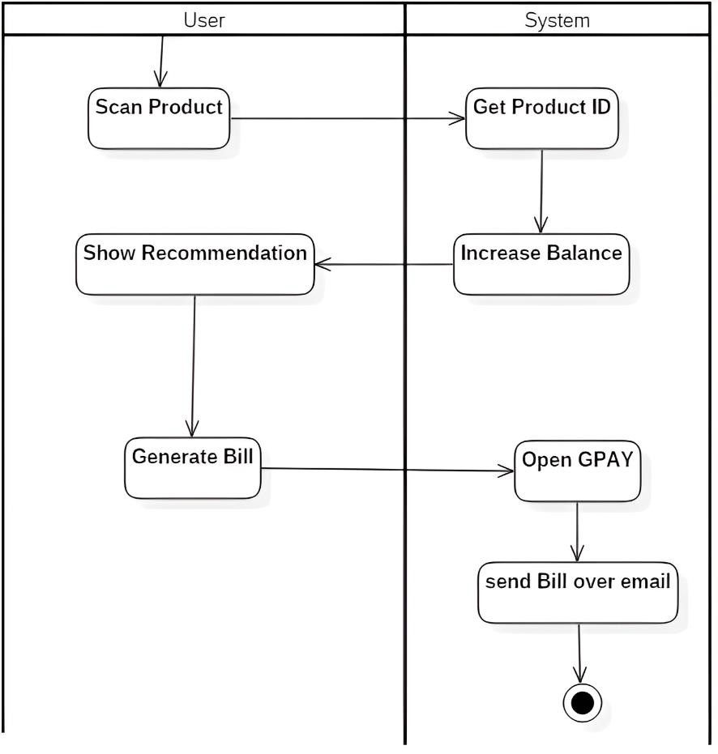

Figure 4.5 Activity Diagram

### Class Diagram:

A class diagram in the Unified modelling Language is a type of static structure diagram that describes the structure of a system by showing the system’s classes, their attributes, operations, and the relationships among objects.

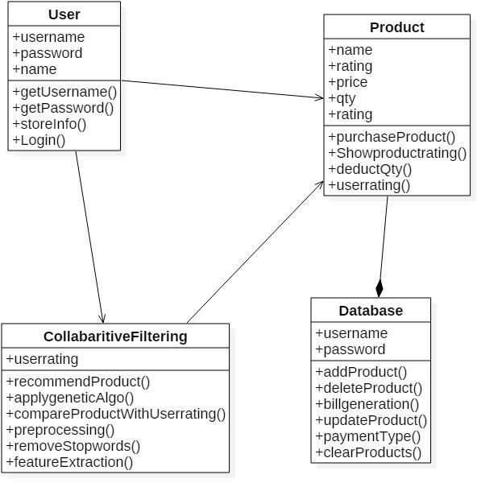

Figure 4.6 Class Diagram

### Component Diagram:

A Component diagram illustrates the pieces of software, embedded controllers and such that make up a system. A Component diagram has a higher level of abstraction than a Class diagram; usually a component is implemented by one or more classes(or objects) at run time. They are building blocks, such that eventually a component can encompass a large portion of a system.

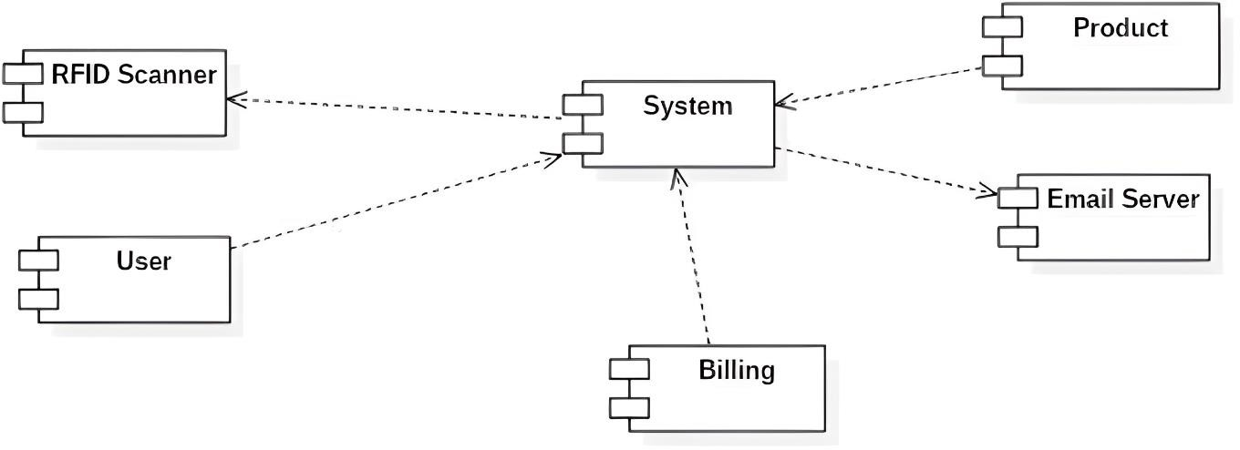

Figure 4.7: Component Diagram

### Deployment Diagram:

Deployment diagrams are used to visualize the topology of the physical component of a system where the software components are deployed. So deployment diagrams are used to describe the static deployment view of a system. Deployment diagrams consist of nodes and their relationships.

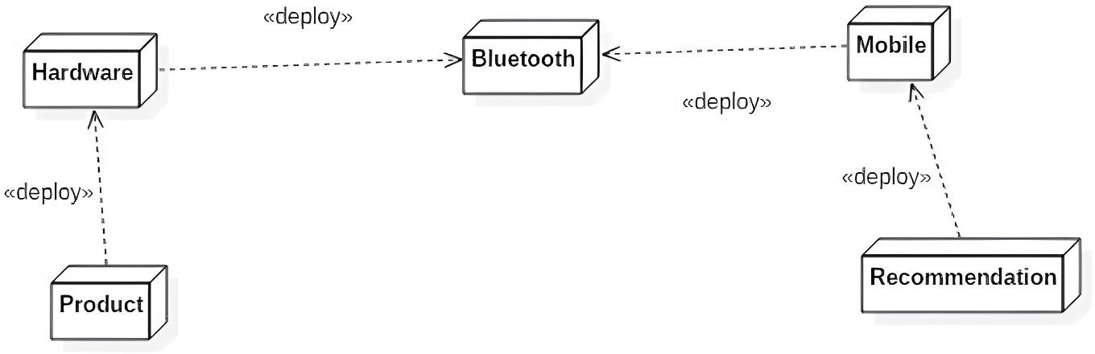

Figure 4.8: Deployment Diagram

Chapter 5

# PROJECT PLAN

## Project Estimates

### Size Estimation:

|  |  |
| --- | --- |
| Software Module | LOC |
| Graphical User Interface | 400 |
| Command Management | 600 |
| OS Interface | 500 |
| RSS Feed | 700 |
| SAPI Test Module | 400 |
| Text To Speech | 700 |
| Speech To Text | 1000 |
| Action Commands Specification | 300 |
| Total Estimated Lines of Code (LOC) | 4600 |

Table 5.1: Size Estimation of Current System

Line of code approximately 5000.

### Effort Estimation:

The value ab and bb according to embedded system is ab=2.8 and bb=1.20

The system falls in the embedded category.

Total LOC (approx) of project is:5000LOC=5.00KLOC Effort (E)

=ab(KLoC)(bb) [Person -Month] E=3.6*(5.00)1.20

E=24.83PM

Person-Month=25PM (approx)

Duration Estimation:

Duration (D) = cb(E )(db)[ months]

= 2.5*(24.83)0.32

= 2.5 *2.7950

= 6.98

Duration 7 [months]

Person Required:

Person Required = Effort Applied (E) / Development Time (D) [count]

= 24.12/7

= 3.44[count]

Person Required =4 Persons

Cost Estimation:

We take the assumption each person charges 6000 rupees per month. Total Estimation= 6,000*4= Rs.24,000/-

Total Estimation=Rs.24,000 /-

### Reconciled Estimates

Cost Estimate:

As the project will be implemented using open source software such as, Linux (fedora 17 ) operating system, and jdk 1.7, which are also hardware independent software, there is very less cost.

Time Estimates:

Roughly project will take around 6 months for implementation and the month there after for testing.

### Project Resources

* + - * Project resources:
        + People : We are four peoples for this project.
        + Hardware : Minimum 3 computer systems and camera.
        + Software : Windows XP/7/8, Linux.
        + Tools and other resources: Java Script, Jdk1.7, Eclipse 1.4, Apache Tomcat 7, MySQL.

## OVERVIEW OF PROJECT

Android 3.6 was used to create the application files. Before running the files, it must be ensured that Android 3.6 and the following libraries are installed. Sklearn :- Machine Learning Library Numpy :- Mathematical Operations Pandas :- Data Analysis Tools Matplotlib :- Graphics and Visuality The implementation phase consists of 5 steps, which are: 1- Pre-processing 2- Statistics 3- Attack Filtering 4- Feature Selection 5- Machine Learning Implementation. Each of these steps contains one or more Android files. The same file was saved with both ”py” and ”ipynb” extensions. The code they contain is exactly the same. The file with the ipynb extension has the advantage of saving the state of the last run of that file and the screen output.

### TECHNOLOGY USED - Android

Android is an interpreted, high-level, general-purpose programming language. Created by Guido van Rossum and first released in 1991, Android has a design philosophy that emphasizes code readability, notably using significant whitespace. It provides constructs that enable clear programming on both small and large scales.Van Rossum led the language community until July 2018. Android is dynamically typed and garbage-collected. It supports multiple programming paradigms, including procedural, object-oriented, and functional programming.

Android features a comprehensive standard library, and is referred to as ”batteries included”. Android interpreters are available for many operating systems. CAndroid, the reference implementation of Android, is open-source software and has a community- based development model. Android and CAndroid are managed by the non-profit Android Software Foundation.

Android is a general-purpose object-oriented programming language with high-level programming capabilities. It has become famous because of its apparent and easily understandable syntax, portability and easy to learn. Android is a programming language that includes features of C and Java. It provides the style of writing an elegant code like C, and for object-oriented programming, it offers classes and objects like Java.

* + - * Android was developed in the late eighties, i.e., late 1980’s by Guido van Rossum at the National Research Institute for Mathematics and Computer Science in the Netherlands as a successor of ABC language capable of exception handling and interfacing.
      * Android is derived from programming languages such as ABC, Modula 3, small talk, Algol-68. Van Rossum picked the name Android for the new language from a TV show, Monty Android’s Flying Circus.
      * Android page is a file with a .py extension that contains could be the combination of HTML Tags and Android scripts.
      * In December 1989 the creator developed the 1st Android interpreter as a hobby and then on 16 October 2000, Android 2.0 was released with many new features. On 3rd December 2008, Android

3.0 was released with more testing and includes new features.

* + - * Android is an open source scripting language., which means that anyone can download it freely from [www.Android.org](http://www.android.org/) and use it to develop programs. Its source code can be accessed and modified as required in the project .Android is one of the official languages at Google.

### Features of Android

1. Easy to Learn and Use. Android is easy to learn and use.
2. Expressive Language. Android language is more expressive means that it is more understandable and readable.
3. Interpreted Language.
4. Cross-platform Language.
5. Free and Open Source.
6. Object-Oriented Language.
7. Extensible.
8. Large Standard Library.

## Collaborative Filtering

Collaborative filtering is a technique that can filter out items that a user might like on the basis of reactions by similar users.

It works by searching a large group of people and finding a smaller set of users with tastes similar to a particular user. It looks at the items they like and combines them to create a ranked list of suggestions.

There are many ways to decide which users are similar and combine their choices to create a list of recommendations.

* Find similar users based on interactions with common items.
* Identify the items rated high by similar users but have not been exposed to the active user of interest.
* Calculate the weighted average score for each item.

Chapter 6

# PROJECT IMPLEMENTATION

## OVERVIEW OF PROJECT

Android Studio is the official integrated development environment (IDE) for Google’s Android operating system, built on JetBrains’ IntelliJ IDEA software and designed specifically for Android development. It is available for download on Windows, macOS and Linux based operating systems. It is a replacement for the Eclipse Android Development Tools (E-ADT) as the primary IDE for native Android application development.

Android Studio was announced on May 16, 2013, at the Google I/O conference. It was in early access preview stage starting from version 0.1 in May 2013, then entered beta stage starting from version 0.8 which was released in June 2014.[9] The first stable build was released in December 2014, starting from version 1.0.[10] At the end of 2015, Google dropped support for Eclipse ADT, making Android Studio the only officially supported IDE for Android development.

On May 7, 2019, Kotlin replaced Java as Google’s preferred language for Android app development. Java is still supported, as is C++.

### TECHNOLOGY USED Android

Android is a mobile operating system based on a modified version of the Linux kernel and other opensource software, designed primarily for touchscreen mobile devices such as smartphones and tablets. Android is developed by a consortium of developers known as the Open Handset Alliance, though its most widely used version is primarily developed by Google. It was unveiled in November 2007, with the first commercial Android device, the HTC Dream, being launched in September 2008.

At its core, the operating system is known as Android Open Source Project (AOSP)[4] and is free and open-source software (FOSS) primarily licensed under the Apache License. However most devices run on the proprietary Android version developed by Google, which ship with additional proprietary closed-source software pre-installed,[5] most notably Google Mobile Services (GMS)[6] which includes core apps such as Google Chrome, the digital distribution platform Google Play, and the associated Google Play Services development platform. Firebase Cloud Messaging is used for push notifications. While AOSP is free, the ”Android” name and logo are trademarks of Google, which imposes standards to restrict the use of Android branding by ”uncertified” devices outside their ecosystem

The source code has been used to develop variants of Android on a range of other electronics, such as game consoles, digital cameras, portable media players, and PCs, each with a specialized user interface. Some well known derivatives include Android TV for televisions and Wear OS for wearables, both developed by Google.

Software packages on Android, which use the APK format, are generally distributed through proprietary application stores like Google Play Store, Amazon Appstore (including for Windows 11), Samsung Galaxy Store, Huawei AppGallery, Cafe Bazaar, GetJar and Aptoide, or open source platforms like F-Droid.

Over 70 percent of smartphones based on Android Open Source Project run Google’s ecosystem (which is known simply as Android), some with vendor-customized user interfaces and software suites, such as TouchWiz and later One UI by Samsung and HTC Sense.[9] Competing ecosystems and forks of AOSP include Fire OS (developed by Amazon), ColorOS by Oppo, OriginOS by Vivo, MagicUI by Honor, or custom ROMs such as LineageOS.

* + - * Android Inc. was founded in Palo Alto, California, in October 2003 by Andy Rubin, Rich Miner, Nick Sears, and Chris White.[13][14]
      * Rubin described the Android project as having ”tremendous potential in developing smarter mobile devices that are more aware of its owner’s location and preferences”.[14] The early intentions of the company were to develop an advanced operating system for digital cameras, and this was the basis of its pitch to investors in April 2004.[15] The company then decided that the market for cameras was not large enough for its goals, and five months later it had diverted its efforts and was pitching Android as a handset operating system that would rival Symbian and Microsoft Windows Mobile.[15][16]
      * Rubin had difficulty attracting investors earlyon, and Android was facing eviction from its office space. Steve Perlman, a close friend of Rubin, brought him 10,000 in cash in an envelope, and shortly thereafter wired an undisclosed amount as seed funding. Perlman refused a stake in the company, and has stated ”I did it because I believed in the thing, and I wanted to help Andy.”

### Features of Android

1. It is open-source.
2. Anyone can customize the Android Platform.
3. There are a lot of mobile applications that can be chosen by the consumer.
4. It provides many interesting features like weather details, opening screen, live RSS (Really Simple Syndication) feeds etc.
5. It provides support for messaging services(SMS and MMS), web browser, storage (SQLite), connectivity (GSM, CDMA, Blue Tooth, Wi-Fi etc.), media, handset layout etc.

## ALGORITHM

### Collaborative filtering:

User-based collaborative filtering makes recommendations based on user-product interactions in the past. The assumption behind the algorithm is that similar users like similar products.

1. Find similar users based on interactions with common items.
2. Identify the items rated high by similar users but have not been exposed to the active user of interest.
3. Calculate the weighted average score for each item.
4. Rank items based on the score and pick the top n items to recommend.

Chapter 7

Software Testing

## Type of Testing Used

White box testing is a testing technique that examines the program structure and derives test data from the program logic/code. The other names of glass box testing are clear box testing, open box testing, logic driven testing or path driven testing or structural testing.

Black-box testing is a method of software testing that examines the functionality of an application without peering into its internal structures or workings. This method of test can be applied to virtually every level of software testing: unit, integration, system and acceptance.

Unit Testing is focuses on the smallest unit of software design i.e. the smallest component or module. Important control paths are tested to uncover errors within the boundary of the module. It focuses on the internal processing logic and data structures within the boundaries of a component. This type of testing can be conducted in parallel for multiple components.

Integration Testing is a systematic technique for constructing the software architecture while at the same time conducting tests to uncover errors associated with interfacing. The different modules in our project were interfaced and tested in small increments, thus making the errors easy to isolate and correct. This is known as incremental integration.

Validation Testing begins at the culmination of integration testing, when individual components have been exercised, software is completely assembled as a package, and interfacing errors have been uncovered and corrected. Here, testing focuses on user visible actions and user recognizable output from the system. Validation succeeds when the software functions in a manner that can be reasonably expected by the customer. In our project, all functions and performance characteristics are tested and they conform to the required specifications and are accepted.

System Testing is the final step in testing. In this phase, we tested the entire system as a whole with all forms, code, modules and class modules. This form of testing is known as Black Box testing or System testing. Black Box testing enables us to derive sets of input conditions that will fully exercise all functional requirements for a program. Black box testing helps to discover incorrect or missing functions, interface errors, errors in data structure, performance errors and initialization and termination errors.

## Test Cases and Test Results

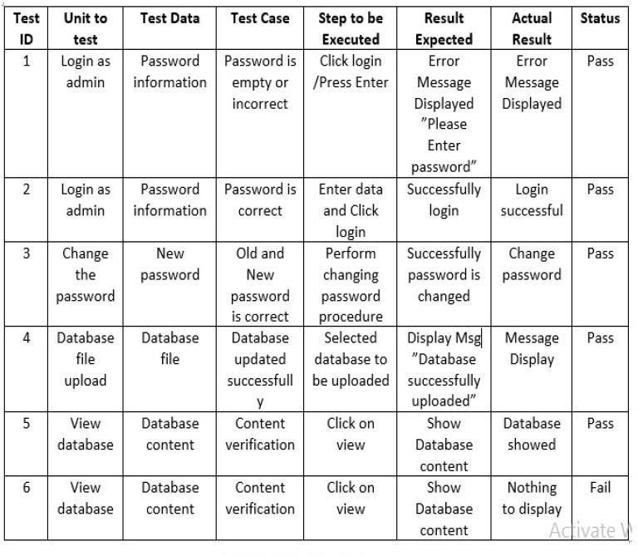

* 1. **Comparison of Existing work:**

To evaluate the recommendation accuracy of two traditional collaborative filtering and two Boosting frameworks, Root Mean Square Error (RMSE) is used on rating history in Book Crossing Dataset with sparsity level of 91%. Below table show comparison.

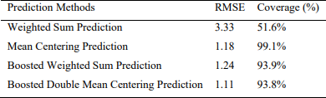

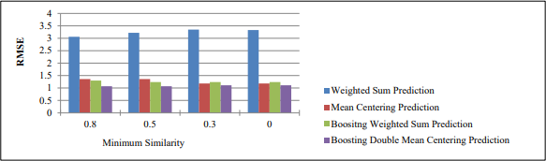

The proposed boosted double mean centering approach can predict least recommendation error than the other method although it has slightly low coverage than the mean centering prediction. RMSE results of the four methods evaluated varying minimum similarity count. The boosted double means centering can predict minimum recommendation error than the other method whatever the amount of nearest neighbors are varied.

Chapter 8

# CONCLUSION

## CONCLUSION

This process not only helps in reducing the waiting time in the long queues and moving the cart automatically but also helps in managing and checking the budget while shopping which indeed provides a huge difference in their shopping experience as well.

Thus with the help of the conclusion we say that, Automatic billing of products by using RFID technique will be a more viable option in the future. The system based on RFID technique is efficient, compact and has promising performance. Also, RFID is better and faster than barcode reading because the later works on line of sight which is not the case for RFID technique. This will take the overall shopping experience to a different level. Different parameters such as the system parameters of smart cart like product name, product cost, product weight etc. are display.

## FUTURE SCOPE

This method can be further enhanced by providing a virtual map of all the products available in the supermarket and so, the customers can easily localize their desired product in the large locality and minimize the large manpower deployed in the supermarkets to aid the customers with their shopping and also propose to automate the payment processing by generating QR code for making payment though mobile payment applications and also make payments through credit or debit card reader or card machine to process payments and further this method with such upgrading’s will not require any bill counters compulsorily at the supermarkets which considerably reduces the cost and efforts of the shop owners and bill counter attenders and also reduce the waiting time of the customers in long queues towards the bill counters.

Chapter 9

# REFERENCES

1. Mr Manikandan and Mr Mohan “RFID Based Shopping cart for Supermarket”, JCHPS, 8 June 2022.
2. Mr S. Balamurugan and Mr S. Balaji “Smart Shopping Cart”, International Conference on Microelectronic Devices, Circuits and Systems (ICMDCS) 10-12 August 2021
3. Mr. P. Chandrasekar,Ms.T. Sangeetha,”Smart Shopping Cart with Automatic Billing System through RFID and ZigBee” in IEEE S.A.Engineering College, Chennai, Tamil Nadu, 2022,India.
4. Akshay Kumar, Abhinav Gupta, S. Balamurugan, S. Balaji and Marimuthu R., ”Smart Shopping Cart” in School of Electrical Engineering, VIT University, Vellore IEEE,2022.
5. Ruinian Li, Tianyi Song, Nicholas Capurso,”IoT Applications on Secure Smart Shopping” in International Conference on Identification, Information and Knowledge in the Internet of Things,2021.
6. Tharindu Athauda, Juan Carlos Lugo Marin, Jonathan Lee, Nemai Karmakar,”Robust low-cost passive UHF RFID based smart shopping cart” in IEEE Journal of Radio Frequency Identification,Issue in 2021.
7. Rajlakshmi Badi, Bashirahamad Momin,”SISC: Sensor-based Intelligent Shopping Cart” in 3rd International Conference for Convergence in Technology (I2CT),Apr 06- 08, 2021 India.

# BASE PAPER:

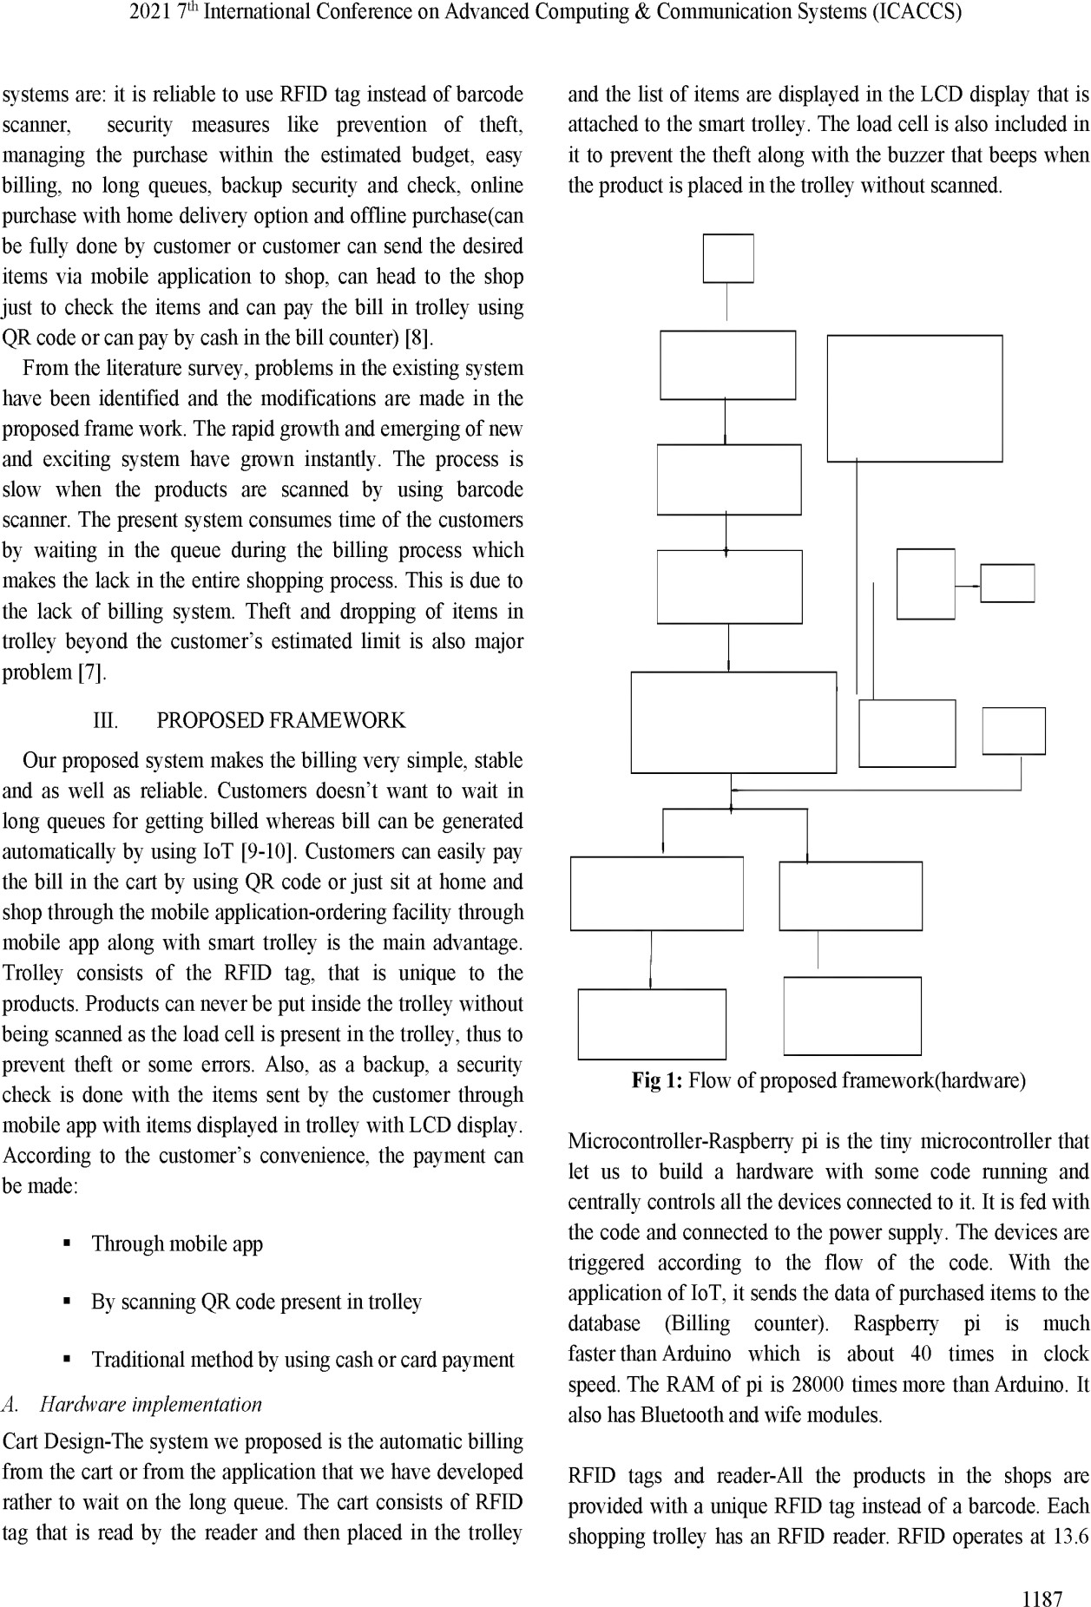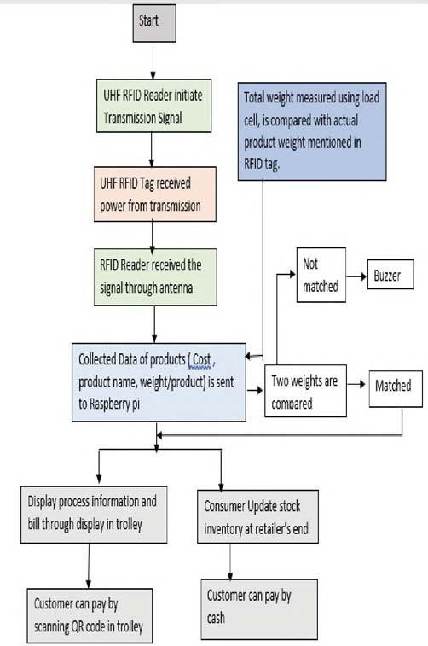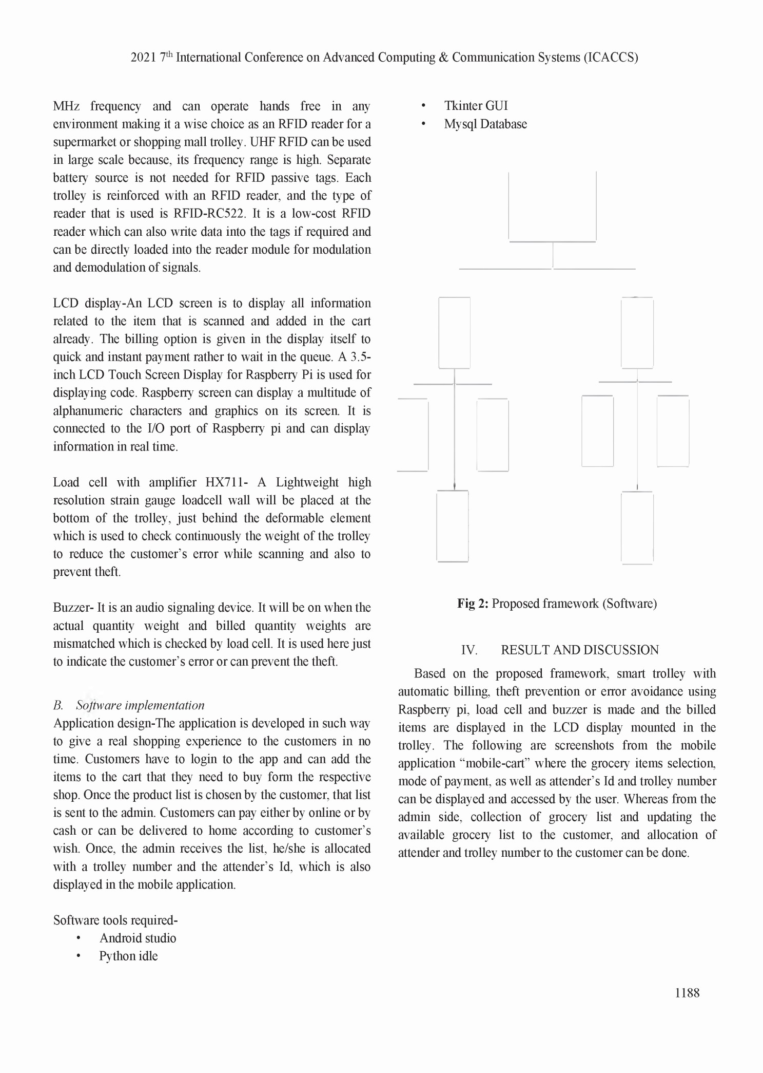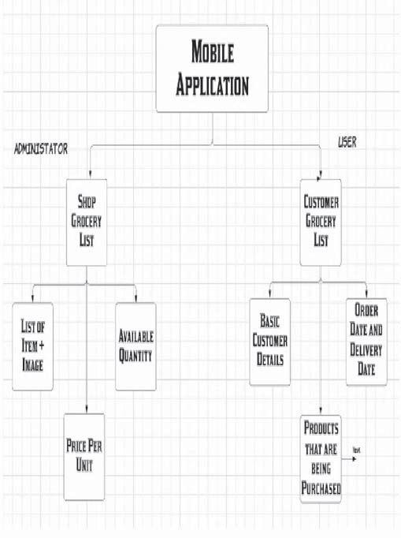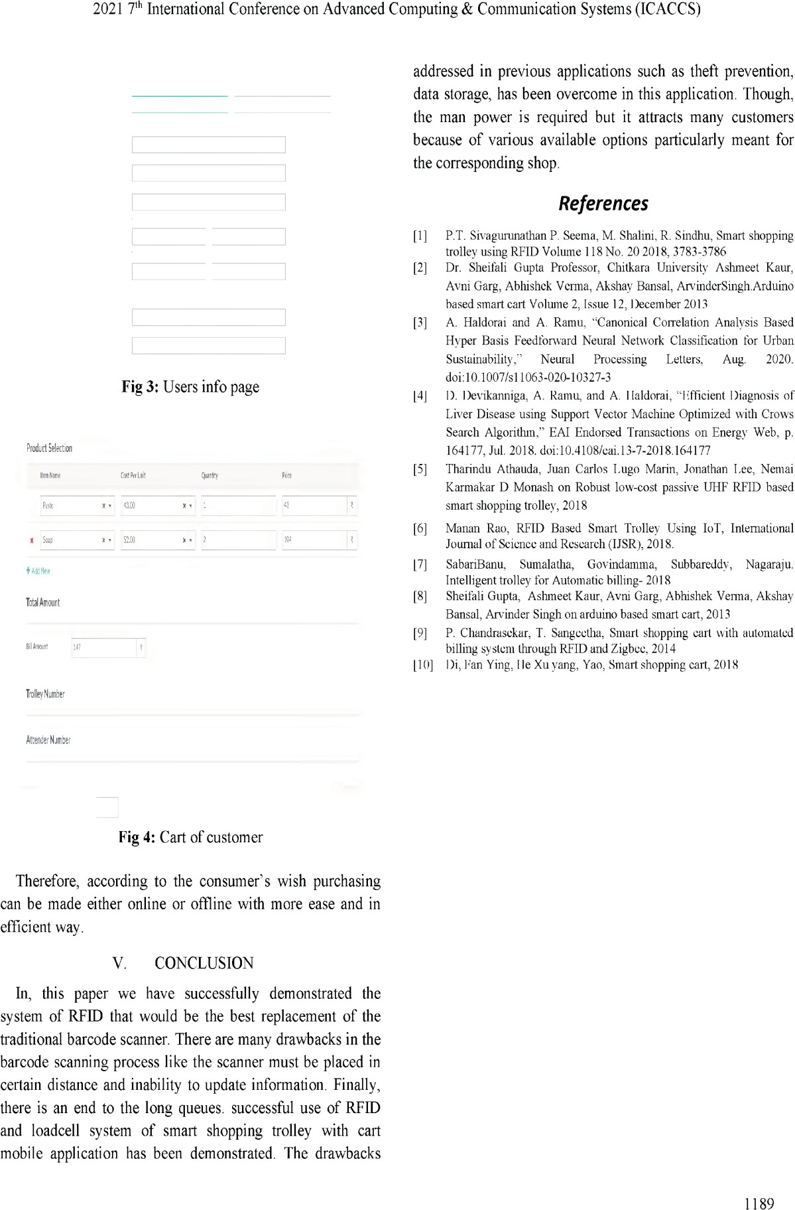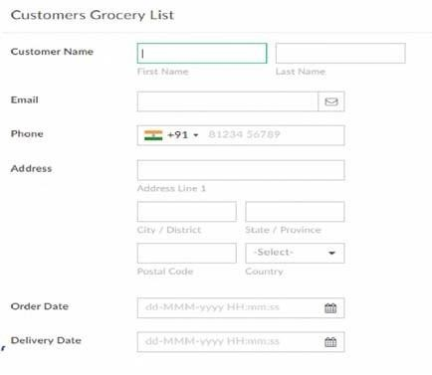

REVIEW PAPER:

Smart Shopping Cart using IOT & Google Firebase

Prof. Kapil Wagh Department of Information Technology

Assistant Professor, Nutan Maharashtra Institute of Engineering and Technology, Talegaon-Pune Maharashtra,India

[Kapilwagh2686@gmail.com](mailto:Kapilwagh2686@gmail.com)

Mr. Yash Virendra Upare Department of Information Technology

Nutan Maharashtra Institute of Engineering and Technology, Talegaon-Pune

Maharashtra,India [yashupare6133@gmail.com](mailto:yashupare6133@gmail.com) 0009000874136839

Mr. Saurabh Umesh Pisal Department of Information Technology

Nutan Maharashtra Institute of Engineering and Technology, Talegaon-Pune

Maharashtra,India [saurabhpisal25@gmail.com](mailto:saurabhpisal25@gmail.com) 0009000524437981

Mr. Vinit Ajit Dhas Department of Information Technology

Nutan Maharashtra Institute of Engineering and Technology, Talegaon-Pune

Maharashtra,India [dhasvinit1@gmail.com](mailto:dhasvinit1@gmail.com) 0009000756631935

Mr.Aditya Manoj Bole Department of Information Technology

Nutan Maharashtra Institute of Engineering and Technology, Talegaon-Pune

Maharashtra,India [adityabole01@gmail.com](mailto:adityabole01@gmail.com) 0009000309770845

**Abstract— In today's 21st century, most families love to spend their time shopping in stores, shops and shops. In all these stores, people usually carry the cart themselves and fill the desired items and then take the cart to the cashier where they have to wait in a long queue, but now they have to convert the old traditional cart to modern Automatic carts, that's what we did. The main idea of this project is to make the purchase, we will scan the RFID device attached to the product and the RFID reader attached to the cart and display all the money on the Android mobile screen. We also provide the ability to send messages to customers' mobile numbers. This system not only reduces long waiting times in queues and moves the carts automatically, but also helps to control and analyze the budget while shopping, which makes a big difference in products. - Automatic carts, recommendations, RFID, notifications, printed products, marketing technology, mobile application integration.**

**Introduction**

Technology has always been an inspiration to create new ideas and connect the world, and today's world has brought

us many ways to connect people with technology, such as the Internet of Things and business automation. Since the beginning of innovation in the world of science and technology, its meaning is to reduce unnecessary problems and make people productive. One of the most important entertainments in today's world is to spend time shopping in stores, shops, etc. Therefore, the innovation in the field of shopping and shopping can be the integration of a smart store where a person can register using his phone number and enjoy purchasing with individual billing, which helps customers control everything. Automatic billing that helps you understand the price at any time during shopping and the difficulty of waiting and queuing in the store. For the desired products, the products will be scanned after being added to the cart using the RFID reader, when the products are added to the cart, the products will be scanned with EM- 18, LCD will be used to display additional products. The cart with all the numbers. Also the automatic movement of the car was done with the help of ultrasonic sensors,

Arduino and motors. Using GSM module helps us to connect the user's mobile phone to the car and when the payment is completed a message is sent to the customer's mobile phone number with the full description of the part price.

* 1. LITERATURE SURVEY

1. Paper Name -: Automated billing using advanced cart

Author -: Chandrasekar Palanisamy, T. Sangita

Analysis-: In this article [1], they made a prototype that every car will be attched with an RFID reader and a RFID receiver. In addition, all products in the store or market will be equipped with RFID tags. Supermarkets are places where consumers buy and pay charges for products which they use daily. For this, it is necessary to calculate the stock and determine the price according to the customer. When we go shopping in the market, we should choose the right products carefully. Then it is busy with the invoices of all the products. Therefore, a system has been prepared to help customers trade smartly. There is an RFID tag that the user can swipe on the RFID scanner and when the swipe is completed, it will get the product ID. Product IDs will be included in the file as an additional fee in the invoice. The recommendations are based on the products in the shopping cart. Recommendations are based on the customer's past purchase history and are presented based on the recommendation. Payment can also be made with an RFID tag added to the cart. The disadvantage is that you cannot pay online, you have to wait in line, and the price is high.

more important information for people. Tips about price, performance, previous purchase signals etc. are important. In this article, we aim to improve the quality of service providers by comparing the reputation scores of each category of specific products on various e-commerce sites. Finally, the number of products can be reduced to one-third of the total product to reach a group of people who are interested in buying the product. Finally, only a few products are suggested to users on a five-point scale, allowing users to filter and purchase them.

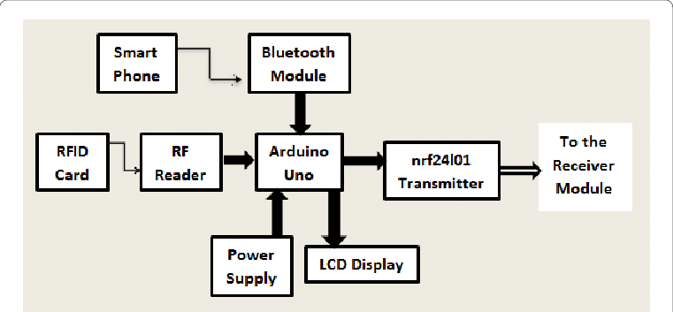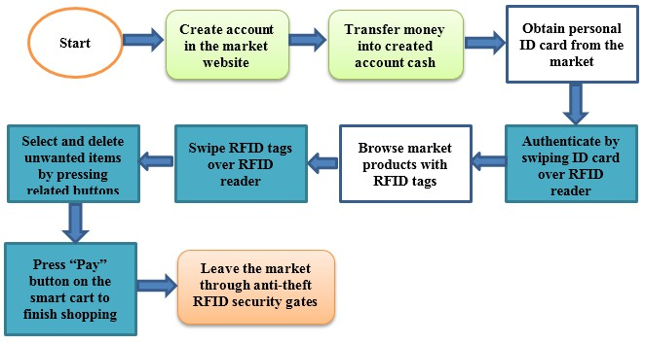

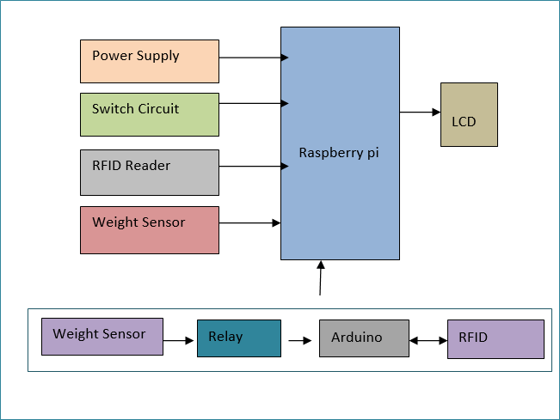

Fig 2. Collaborative Product Recommendation

System

1. Paper Name-: The automated shopping trolley for supermarket billing system

Author-:Sainath (2014)

Analysis-: Customers who use barcodes for product pricing scan products using barcode technology. The invoice will be sent to the billing system and the customer will make payment by presenting a unique ID. Prohibited barcode scanning requires line of sight and must be fixed in line of sight.

Fig 1. Smart Cart with Automatic Billing

1. Paper Name-:Collaborative Product Recommendation System for E-commerce Websites

Author-: S. Ganesh Sundaram Publisher-: IEEE

Analysis-: Product information is important in convincing customers to buy the right product on any e-commerce site. User reviews on the internet are based on the experience of each user and this will be

Fig 3. Automated shopping trolley

1. Paper Name-: Cash register line optimization system using RFID technology.

Analysis: RFID is used to scan the product, the data is stored on file, and payment can be made online or through a central payment system. It also uses the website to manage all purchase details. It is necessary to manage web application servers.We don’t put attention on the product which user or the items that customers throw into the cart.

1. Paper Name-: Smart shopping cart based on Internet of Things

Author -: Dhavale Shraddha (2016)

Analysis: This article uses RFID technology to make payments when purchasing products from the store and establish an Internet price management system through the ESP module. The payment details are transferred from the payment center to the server that enables the customer to make the payment. The ESP module will be used as a short Wi-Fi chip for wireless communication. However, there are also disadvantages, including limitations such as distance and interference. If there are many customers, the server will be very busy, and the network connection must be stable to complete the transaction.

1. Paper Name-: Smart shopping cart using RFID Author: Komal Ambekar (2015)

Analysis-: Customers who use barcodes for product pricing scan products using barcode technology. The invoice will be sent to the billing system and the customer will make payment by presenting a unique ID. Prohibited barcode scanning requires line of sight and must be fixed in line of sight.

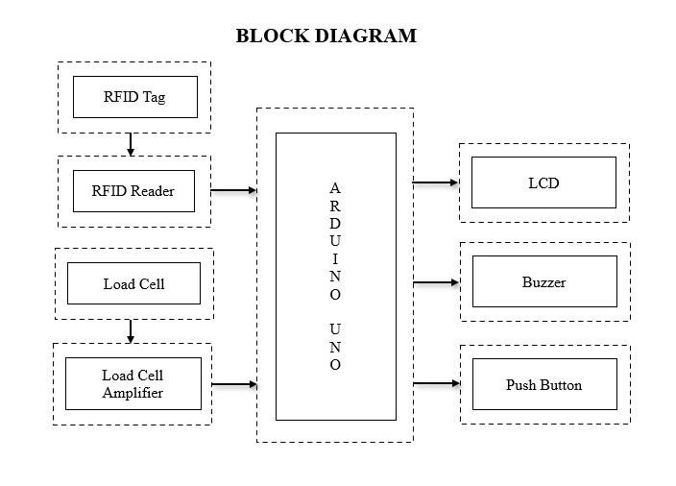

Fig 4. Smart Shopping Cart RFID

1. Article Title-: Customer-Oriented Big Car Author: Hsin-Han Jiang (2016),

Observation: This article uses people using non- standard technology with automatic payment for the face of the concept to recognize the customer. identity verification. This is not an easy way because the store is crowded, so it is not easy or accurate for customers to recognize the face in the store. Some errors may occur when using measurement methods. RFID for sales. They use a special website for billing and user

interaction. Each user with a unique ID can access the web server to store bills and billing information. In such services, network services need to be provided. Therefore, the operation may fail because the network is unstable or overloaded, causing the server to fail. (2014) )

Observation: This article uses default values for the server side. It uses RFID to scan items, then generate invoices on the server side, and then link the invoices to customers. This requires server maintenance and network connectivity from both the customer and the store owner. Explain the process of completing and changing the price in your shopping cart. Connect to the user's Android phone via Bluetooth. Not all customers have a smartphone and Bluetooth may have connectivity issues and various limitations. Suganya Autonomous Smart Trolley for Smart Billing with Arduino (2016) creates a business automation and Android application using Arduino that always requires a network connection. Not all customers have or have a phone with Android OS. : Science Direct

Observation-: This article describes a smart trolley that can use RFID tags to track purchases and payments. It will scan the shopping cart for payment and checkout. In today's world, shopping has become a daily chore. We can see long queues waiting to pay in many stores. The aim of our project is to overcome errors and prevent time loss. To overcome the above problems, we propose a smart cart that can scan products and make online payment using RFID tags. It automatically recognizes and recognizes the product and the final payment is done by the shopping cart itself. Therefore, customers do not need to wait for a long time. It also has RFID-based power management. This model is necessary and useful for the new functioning of the Internet of Things in smart cars. The main purpose is to provide a tool, save time and create a business-oriented product. The system will also provide product recommendations based on the customer's purchase history. In our project, we will attach an RFID tag to each product in each shopping cart. These features will save time and make shopping easier. We can have the best overall shopping experience.

* 1. SYSTEM ARCHICTECTURE

We will use ESP32 which will be connected to android app using Bluetooth

Hardware will be develop using Ultrasonic sensor and RFID scanner/reader. Whenever user put the product in trolley it will send notification to android app.

Price will be updated on the android app

User will register using the android app where they fill the personal details.

Checkout of product will be done using google pay

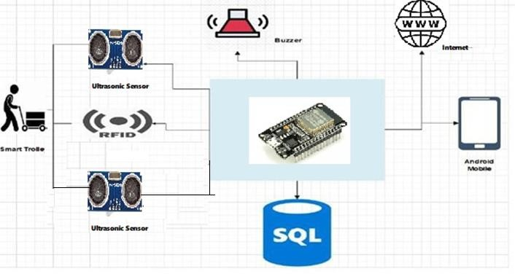

Fig 1. Architecture Diagram

* 1. MODULE
  2. Customer Registration and Login

The customer has to first create his account on the app. The customer details will be saved on the web server.

* 1. Database for shop The shop database will contain all the data regarding each component. The customer's account data as well as the billing data will also be stored here.
  2. Shopping Trolley Selection Once the user logs in to the mobile app they will have a prompt to scan available shopping trolleys. The shopping trolleys will be identified will an SSID with a specific pattern. Once the user has scanned all the trolleys he can select a specific one.
  3. RESULT

After developing a hardware prototype and software this is how our project looks like .

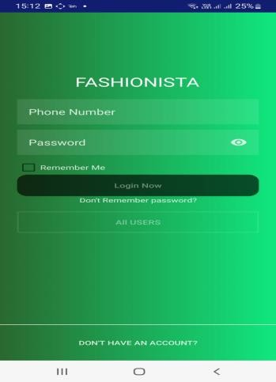

* 1. CONCLUSION

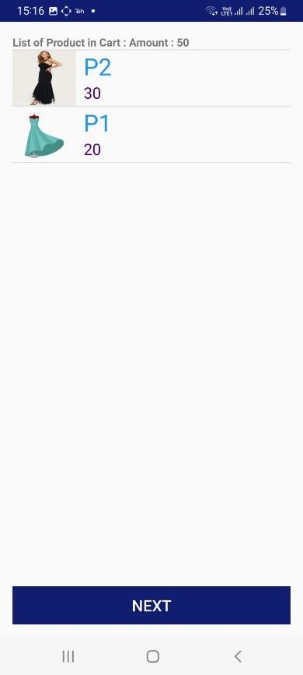Overall, the development of this system is a major achievement in sales technology. This innovative solution combines the convenience of electronic billing with the power of real-time product data and personalized recommendations, ultimately improving the customer experience. Not only does it simplify the checkout process, save customers time, and reduce errors, but it also provides rich product information that supports informed purchasing decisions. It also uses advanced algorithms and data analytics to match product recommendations, provide personalized preferences, and engage shoppers. The combination of these capabilities makes smart shopping carts a great solution for both merchants and consumers, optimizing the retail ecosystem while improving the products people use.

VI References

1. Mr. Manikandan and Mr. Mohan “RFID Based Shopping Trolley for Supermarket”, JCHPS,8 June 2022.
2. Mr. S. Balamurugan and Mr. S. Balaji “Smart Shopping Cart”, International Conference on Microelectronic Devic es, Circuits and Systems (ICMDCS) 10-12 August 2021
3. Mr. Kumar and Mr. Gupta. A “Smart Trolley using Arduino”, International Journal of Advanced Research in Computer Engineering & Technology (IJARCET),12 December 2020.
4. A. Yewatkar, F. Inamdar, R. Singh, Ayushya and A. Bandal, Smart cart with Automatic Billing, Product Information, Product Recommendation Using RFID & Zigbee with Anti-Theft”, Proceedings of 7th international conference on communication, computing.
5. D. P. Acharjya and T. K. Das, “A framework for attribute selection in marketing using rough computing and formal concept analysis”, IIMB Management Review, Vol. 29, pp.122–135, 2017. [3] G. Roussos, “Enabling RFID in

retail”, Computer, Vol. 39, No. 3, pp. 25-30, 2006.

1. H. H. Chiang et al., “Development of smart shopping carts with customer-oriented service”, in proc. of International Conference on System Science and Engineering, Taiwan, pp. 1-2, 2016.
2. L. Yathisha, A. Abhishek, R. Harshith, S. R. D. Koundinya and K. M. Srinidhi, “Automation of shopping cart to ease queues in malls using RFID”, International Research Journal of Engineering and Technology, Vol. 2, No.3, pp.1435-1441, 2015.
3. S. Sojitra1 and R. G. Patel, “A Review of Smart Shopping Systems”, International Research Journal of Engineering and Technology, Vol. 3, No. 5, pp. 2561-2563,

2016.

1. S. Kamble, S. Meshram, R. Thokal and R. Gakre, “Developing a Multitasking Shopping Trolley Based on RFID Technology”, International Journal of Soft Computing and Engineering, Vol.3, No.6, pp.179- 183.2014
2. T. K. Das, “A Customer Classification Prediction Model Based on Machine Learning Techniques”, in proceedings of IEEE International Conference on Applied and Theoretical Computing and Communication Technology, pp. 321-326, 2015.
3. T. Nakahara and K. Yada “Evaluation of the Shopping Path to Distinguish Customers Using a RFID Dataset”. International Journal of Organizational and Collective Intelligence archive, Vol. 2, No.4, pp. 1-14. 2011
4. Y. Kambayashi, Y. Harada, O. Sato, and M. Takimoto, “Design of an intelligent cart system for common airports”, Consumer Electronics, ISCE \'09. IEEE 13th International Symposium, pp.523-526, 2009.
5. Z. Ali and R. Sonkusare, “RFID Based Smart Shopping and Billing”, International Journal of Advanced Research in Computer and Communication Engineering, Vol. 2, No.12, pp. 4696-4699.2013

Chapter 10

SPONSORSHIP LETTER

